**A REPORT ON**

SOCIAL NETWORKING SITE

**PROJECT REPORT**

SUBMITTED IN PARTIAL FULFILLMENT OF THE REQUIREMENT FOR THE AWARD OF THE DEGREE OF

##### BACHELOR OF TECHNOLOGY

(Computer Science & Engineering)

**SUBMITTED BY**

##### (Gaurav Sharma, 1902060, 6sem D1)

**UNDER THE GUIDANCE OF**

Dr. Parveen Sharma

Assistant profession (CSE DEP)



**Department of Computer Science & Engineering Chandigarh Engineering College**

Kharar-Banur Highway, Sector-112 Greater Mohali, Punjab – 140307 (INDIA)

(Approved by AICTE, New Delhi and Affiliated to IKGPTU, Jalandhar)

DECEMBER 2022



**CHANDIGARH ENGINEERING COLLEGE, CGC- LANDRAN, MOHALI**

**CANDIDATE'S DECLARATIO**N

I hereby certify that the work which is being presented in the project report entitled “Social Networking Site” by “Gaurav Sharma” in partial fulfillment of requirements for the award of degree of B.Tech. (CSE) submitted in the Department of CSE at Chandigarh Engineering College under PUNJAB TECHNICAL UNIVERSITY, JALANDHAR is an authentic record of my own work carried out during a period from to

under the supervision of Dr. Praveen Sharma

Name & Signature of the Student

This is to certify that the above statement made by the candidate is correct to the best of my/our knowledge.

The B.Tech Viva –Voce Examination of Gaurav Sharma has been held on

and accepted.

**Dr. Praveen Sharma Assistant profession (CSE DEP)**

**ACKNOWLEDGEMENT**

I would like to place on record my deep sense of gratitude to *Dr. Praveen Sharma* Dept. of Computer Science & Engineering, CEC-CGC, landran for his/her generous guidance, help and useful suggestions.

I express my sincere gratitude to Dr. Sukhpreet Kaur, HoD in Department of CSE, CEC- CGC, Landran for her stimulating guidance, continuous encouragement.

I also wish to extend my thanks to for their insightful comments and constructive suggestions to improve the quality of this research work.

**Gaurav Sharma (1902060, 6 Sem, D1)**

.

|  |  |  |
| --- | --- | --- |
|  | **CONTENTS** | Page No |
| *Candidate's Declaration* |  | *i* |
| *Abstract* |  | *ii* |
| *Acknowledgement* *List of Figures* |  | *viii* *xvi* |
| *List of Tables* |  | *xxii* |

1. INTRODUCTION* 1
   1. Problem Definition 1
   2. Project Overview/Specifications* (page-1 and 3) 2
   3. Hardware Specification 3
   4. Software Specification 4
2. LITERATURE SURVEY 5
   1. Existing System 5
   2. Proposed System 6
   3. Feasibility Study* (page-4) 7
3. SYSTEM ANALYSIS & DESIGN
   1. Requirement Specification* (page-2) 9
   2. Flowcharts / DFDs / ERDs 10
   3. Design and Test Steps / Criteria 12
   4. Algorithms and Pseudo Code 16

3.3.1 18

3.3.2 19

* 1. Testing Process 22

1. RESULTS / OUTPUTS 40
2. CONCLUSIONS / RECOMMENDATIONS 47
3. REFERENCES 49
   1. **Project Definition**

# INTRODUCTION

A social networking service (also social networking site or social media) is an [online platform which people use to build social networks or social relationships](https://en.wikipedia.org/wiki/Social_relation) with other people who share similar personal or career interests, activities, backgrounds or real-life connections.

Social networking services vary in format and the number of features. They can incorporate a range of new information and communication tools, [operating on desktops](https://en.wikipedia.org/wiki/Desktop_computer) and on [laptops](https://en.wikipedia.org/wiki/Laptop), on mobile devices such as [tablet computers](https://en.wikipedia.org/wiki/Tablet_computer) and [smartphones](https://en.wikipedia.org/wiki/Smartphone). They may feature digital photo/video/sharing and diary entries online (blogging). [Online community](https://en.wikipedia.org/wiki/Online_community) services are sometimes considered social-network services by developers and users, though in a broader sense, a social-network service usually provides a individual-centered service whereas online community services are group- centered.

Defined as "websites that facilitate the building of a network of contacts in order to exchange various types of content online," social networking sites provide a space for interaction to continue beyond in person interactions. These computer mediated interactions link members of various networks and may help to both maintain and develop new social and professional relationships. Social networking sites allow users to share ideas, digital photos and videos, posts, and to inform others about online or real-world activities and events with people in their network. While in-person social networking – such as gathering in a village market to talk about events – has existed since the earliest development of towns, the web enables people to connect with others who live in different locations, ranging from across a city to across the [world. Depending on](https://en.wikipedia.org/wiki/Social_media) [the social media](https://en.wikipedia.org/wiki/Social_media) platform, members may be able to contact any other member. In other cases, members can contact anyone they have a connection to, and subsequently anyone that contact has a connection to, and so on.

The success of social networking services can be seen in their dominance in society today, with Facebook having a massive 2.13 billion active monthly users and an average of 1.4 billion [daily active users](https://en.wikipedia.org/wiki/Daily_active_users) in 2017. [LinkedIn](https://en.wikipedia.org/wiki/LinkedIn), a career-oriented social-networking service, generally requires that a member personally know another member in [real](https://en.wikipedia.org/wiki/Real_life) [life](https://en.wikipedia.org/wiki/Real_life) before they contact them online. Some services require members to have a pre- existing connection to contact other members.

## Project Overview/Specifications

#### How to Build With PHP/Create Social Networking Website like Facebook , Twitter?

Wanted to build your own Social Networking Website? And don’t know where to start from? Don’t worry, this project will show you step by step how to create your own Twitter Clone using PHP, MySQL, JQuery

#### As you may already know Twitter is one of the most popular and best Social Networking Website. So why not learn to make your own Twitter Social Networking website?

It doesn't matter if your a beginner or an experienced programmer, just you have to know the basics of PHP, MySQL, HTML ,CSS and JQuery.

* 1. **Hardware Required.**

#### DESKTOP PC

* + - LAPTOP



#### (Desktop PC)

(Laptop)

### Software Required.

* WINDOWS / MAC / LINUX (Operating System)
* XAMPP (Local Server)
* CODE EDITTOR (Visual Studio Codes)

#### Basic knowledge of PHP, HTML, CSS,Javascript and jQuery. (Lamp Stack)





 

### LITERATURE SURVEY

### Existing System

Social networking sites allow users to share ideas, digital photos and videos, posts, and to inform others about online or real-world activities and events with people in their network. While in-person social networking – such as gathering in a village market to talk about events – has existed since the earliest development of towns, the web enables people to connect with others who live in different locations, ranging from across a city to across the [world. Depending on the social media](https://en.wikipedia.org/wiki/Social_media) platform, members may be able to contact any other member. In other cases, members can contact anyone they have a connection to, and subsequently anyone that contact has a connection to, and so on. The success of social networking services can be seen in their dominance in society today, with Facebook having a massive 2.13 billion active monthly users and an average of 1.4 billion [daily active users](https://en.wikipedia.org/wiki/Daily_active_users) in 2017. [LinkedIn](https://en.wikipedia.org/wiki/LinkedIn), a career-oriented social-networking service, generally requires that a member personally know another member in [real life](https://en.wikipedia.org/wiki/Real_life) before they contact them online. Some services require members to have a pre-existing connection to contact other members.[The main types](https://en.wikipedia.org/wiki/Psychographics) [of social networking services contain category places](https://en.wikipedia.org/wiki/Psychographics) (such as age or occupation or religion), means to connect with friends (usually with self- description pages), and a recommendation system linked to trust. One can categorize social-network services into four types:

### socializing social network services used primarily for socializing with existing friends.

* + - **online social networks are decentralized and distributed computer networks where users communicate with each other through internet services.**

### networking social network services used primarily for non-social interpersonal communication.

* + - [**social navigation**](https://en.wikipedia.org/wiki/Social_navigation) **social network services used primarily for helping users to find specific information or resources.**

### Proposed System

* + - Good understanding of languages like HTML5, CSS3 , JAVASCRIPT for frontend development.
    - Good understanding of backend technologies like PHP and storing users data in database. Like MySQL.
    - Build your own social networking website like Twitter or Facebook with most amazing features such as newsfeeds, profiles, Follow system, chat system, trending post and much more!
    - Know how to easily use PDO with MySQL databases
    - Learn how to develop using an PHP OOP (Object Oriented) approach
    - Basic understanding of Windows Operating System
    - Basic understanding of XAMPP (Local Server)
    - Basic of Front-End Development Languages (HTML, CSS, JAVASCRIPT)
    - Basic of Back-End Development languages (PHP, Python, Perl)

### Feasibility Study

Social media is computer-based technology that facilitates the sharing of ideas, thoughts, and information through the building of virtual networks and communities. By design, social media is internet-based and gives users quick electronic communication of content. Content includes personal information, documents, videos, and photos. Users engage with social media via computer, tablet or smartphone via web-based software or web application, often utilizing it for messaging.

While social media is ubiquitous in America and Europe, China and India now lead the list of social media usage.

##### Understanding Social Media

Social media originated as a way to interact with friends and family but was later adopted by businesses which wanted to take advantage of a popular new communication method to reach out to customers. The power of social media is the ability to connect and share information with anyone on Earth, or with many people simultaneously.

Globally, there are more than 3 billion social media users. Social media is an ever- changing and ever-evolving web-based platform.

According to the [Pew Research Center](http://www.pewinternet.org/fact-sheet/social-media/), social media users tend to be younger. Nearly 90 percent of people between the ages of 18 and 29 used at least one form of social media. Further, these users tend to be better educated and relatively wealthy, or earning over $75,000 per year.

**KEY TAKEAWAYS**

* Social media is computer-based technology that facilitates the sharing of ideas, thoughts, and information through the building of virtual networks and communities.
* Social media typically features user-generated content and personalized profiles.
* An estimated 69 percent of Americans used social media as of 2018

##### The Many Forms of Social Media

Social media may take the form of a variety of tech-enabled activities. These activities include photo sharing, blogging, social gaming, social networks, video sharing, business networks, virtual worlds, reviews and much more. Even governments and politicians utilize social media to engage with constituents and voters.

For individuals, social media is used to keep in touch with friends and extended family. Some people will use various social media applications to [network](https://www.investopedia.com/terms/n/networking.asp) career opportunities, find people across the globe with like interests, and share their thought, feelings, insight, and emotions. Those who engage in these activities are part of a virtual [social network](https://www.investopedia.com/terms/s/social-networking.asp).

## SYSTEM ANALYSIS & DESIGN

* 1. **Requirement Specification**

**Hardware Required.**

#### DESKTOP PC

* + - LAPTOP



### Software Required.

* + - WINDOWS / MAC / LINUX (Operating System)
    - XAMPP (Local Server)
    - CODE EDITTOR (Visual Studio Codes)
    - Basic knowledge of PHP, HTML, CSS, JavaScript and jQuery. (Lamp Stack)



### Programming Language

* + - Html, CSS, JavaScript (Front-End Development)
    - (PHP or PERL or PYTHON) (Back-End Development)
    - Basic of OBJECT-ORIENRTED PROGRAMMINGs
  1. **Flowcharts / DFDs / ERDs**

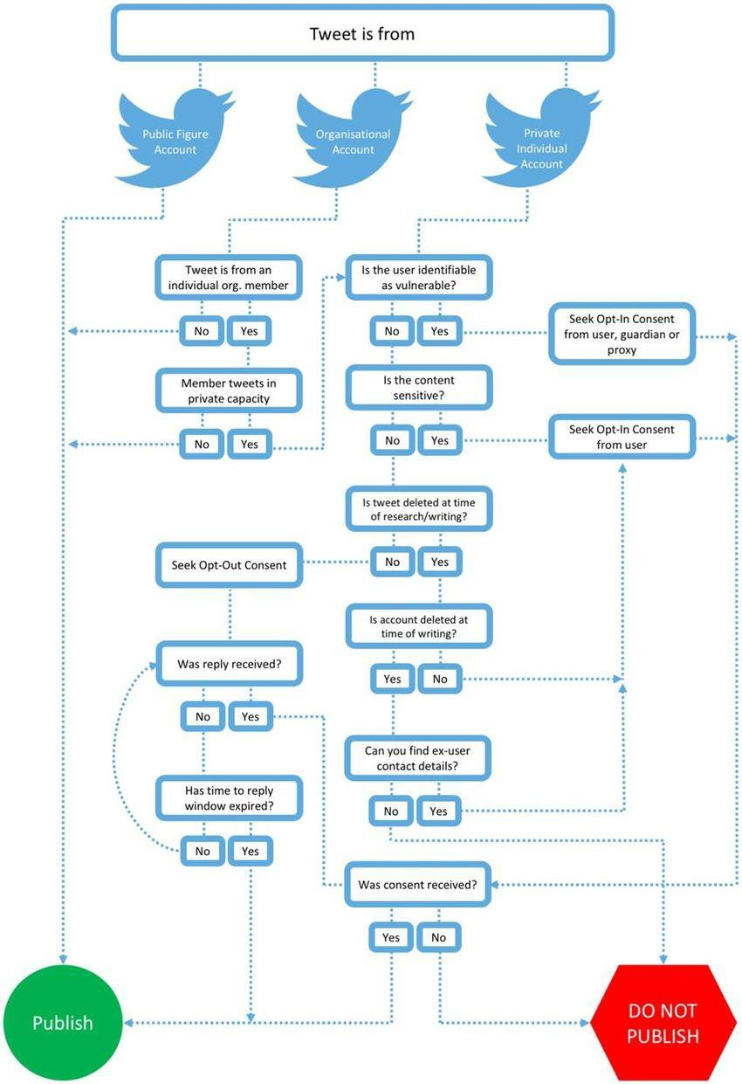

# Algorithms and Pseudo Code

**(The entire source code of this project is present on GitHub click On the link:-** [**https://github.com/gsharma101/Twitter-Social-Network-**](https://github.com/gsharma101/Twitter-Social-Network-Clone)[**Clone**](https://github.com/gsharma101/Twitter-Social-Network-Clone) **)**

**These are some of the code of this project**

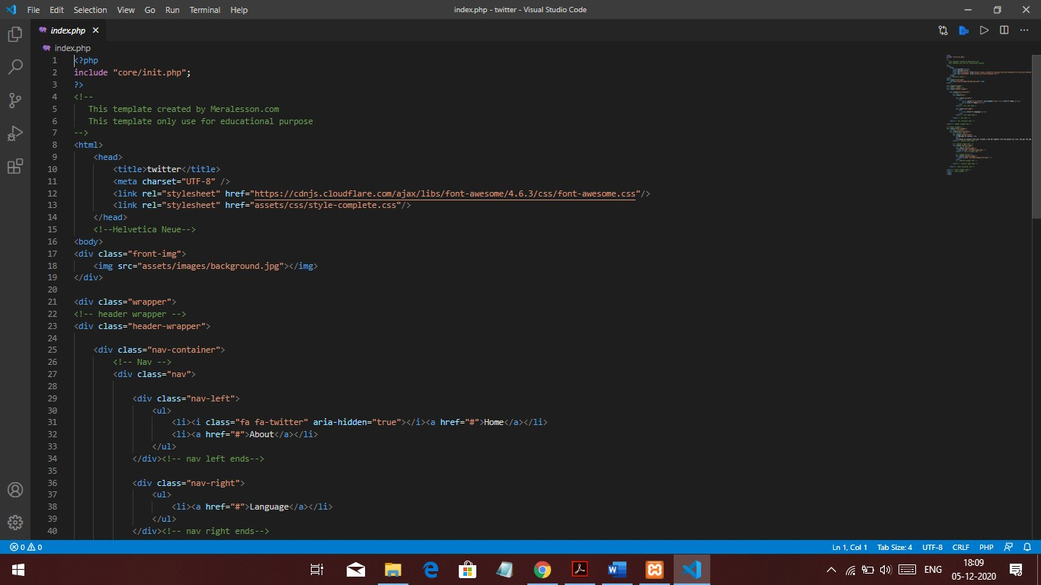

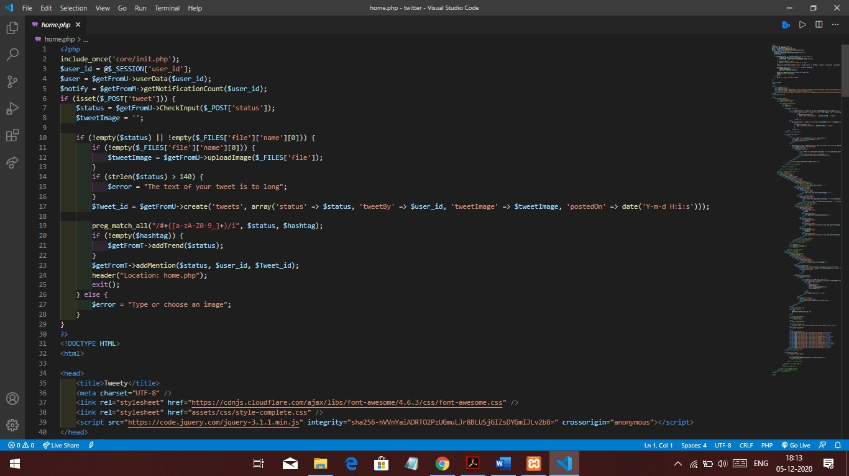

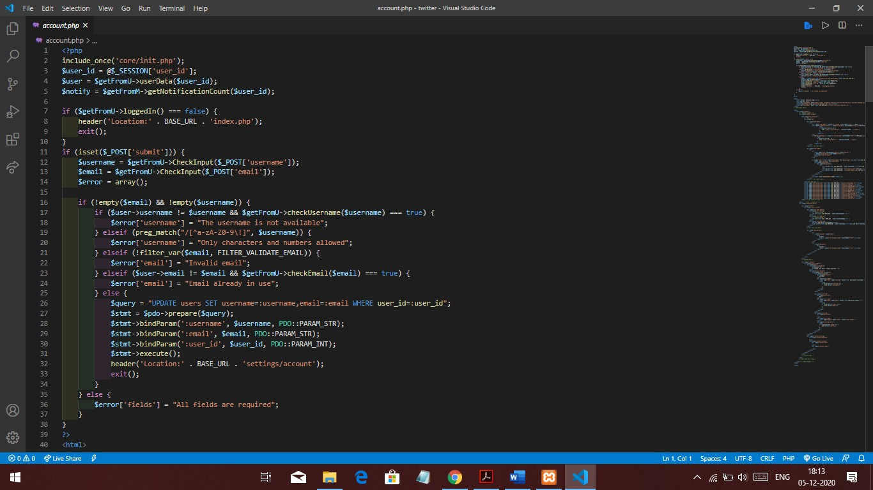

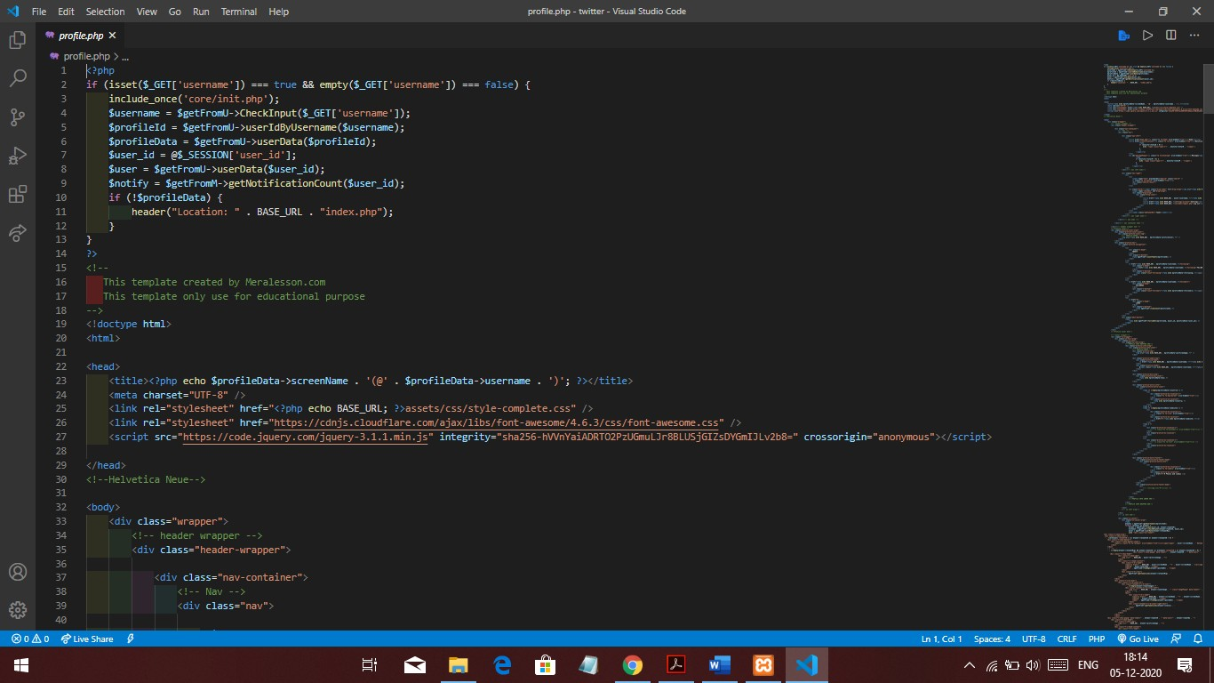

**RESULT AND OUTPUT**

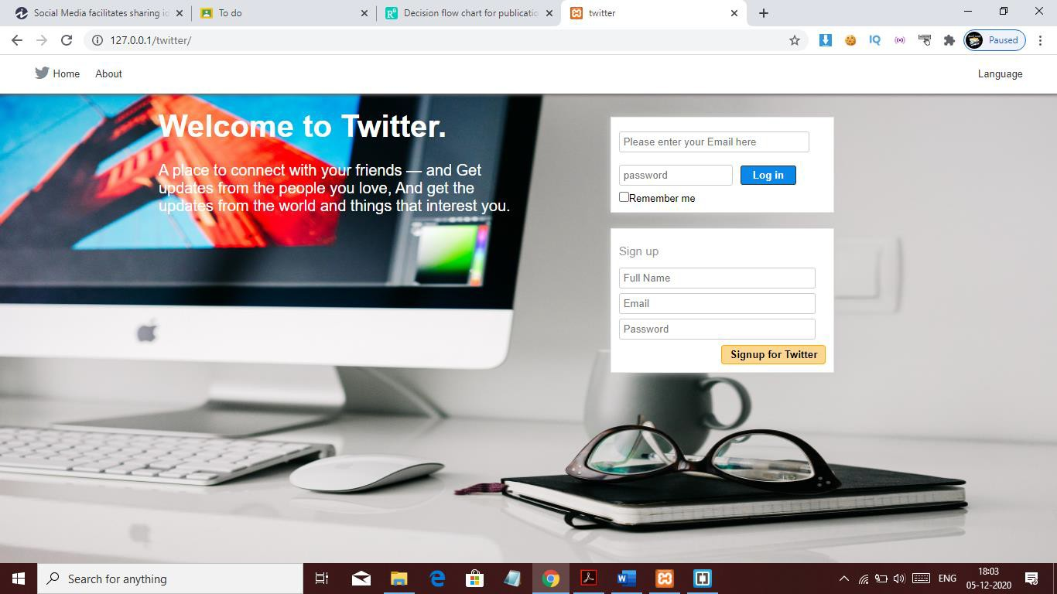

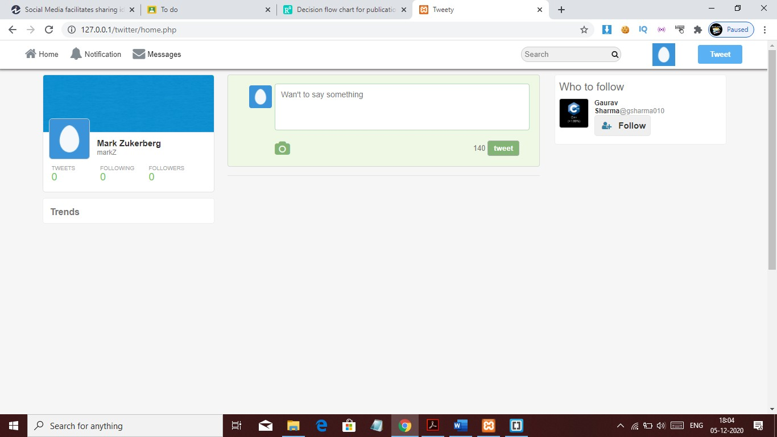

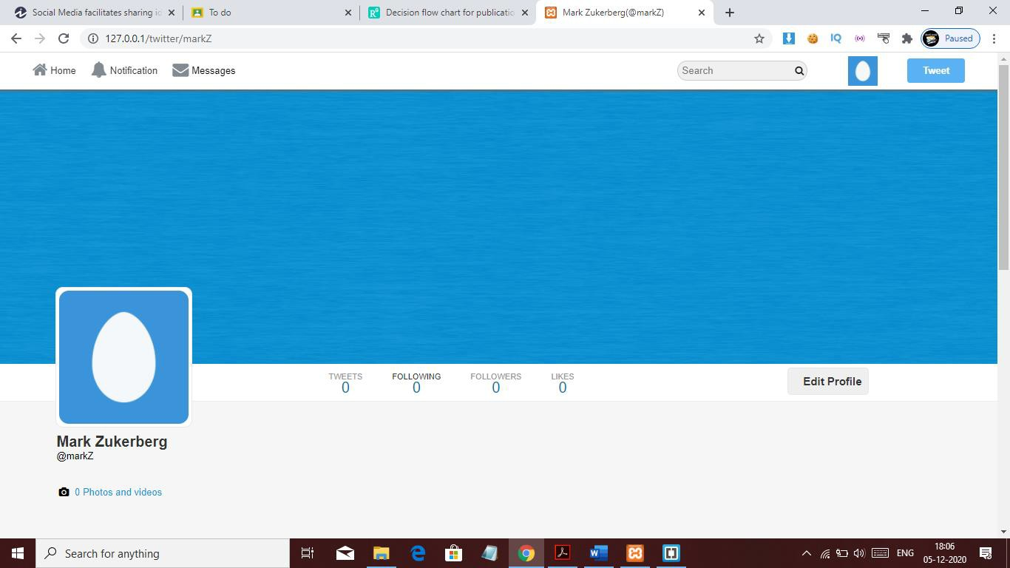

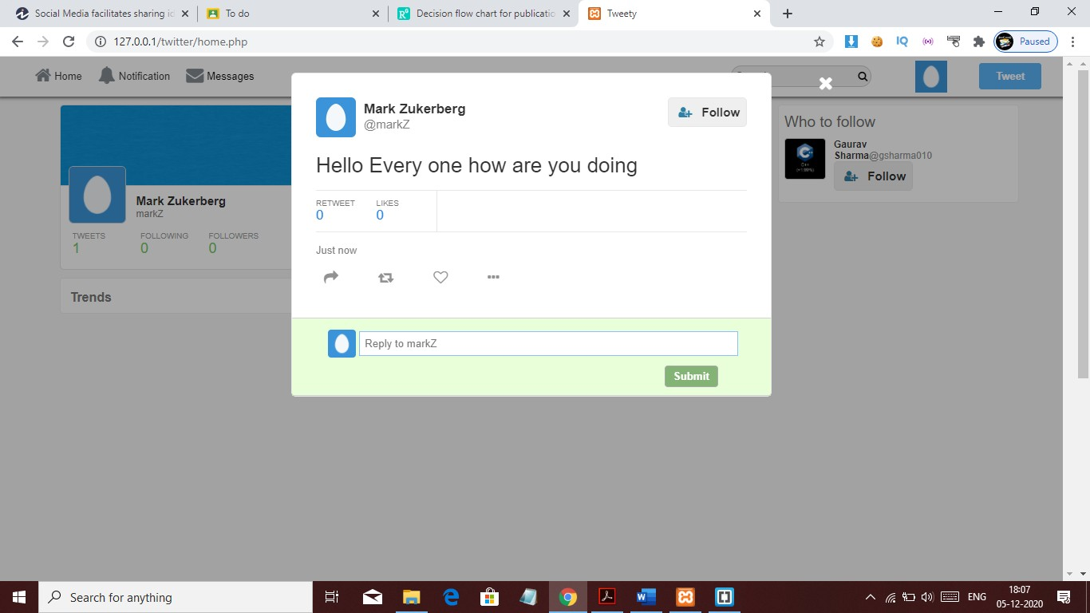

**CONCLUSIONS / RECOMMENDATIONS & REFERENCES**

**Twitter-Social-Network-Clone**

Create a Twitter Social Network Clone From Scratch PHP,MySQL

* Login & Sign-up Systems
* Users Profiles
* Users Timeline
* Users Tweets
* Users Retweets
* Users Comments
* News Feeds
* Hashtags & Mention Users
* Top Trending Posts
* Posts & Images Popups
* Messages and Chat System
* Follow and Unfollow System
* Notification System

•And Much More.